**Plans and Progress**

Hans Christian Anderson once said, “To travel is to Live”[1]. This is the motivation of this project. Last year the travel and tourism sector contributed $9.45tr USD[2] to the global economy. Having researched these kinds of statistics, it is easy to see why we are pursuing this kind of project. There is a multitude of different apps out there which do the same thing, book travel plans. Voyage is different, we aim to be more than that, Voyage is your travel companion. Planning and booking a trip can be super stressful, but no longer do you need to worry about all the little details. We have your back. Our project is feature packed! I have detailed below the features that will be included.

**Travel Planner**

This is the nuts and bolts of the app, the most basic function that is why we decided to embark on this venture. Here you can search for your destination and read reviews on previous travelers and decide where you want to go. Pick your date, find flights and accommodation and even transportation and transfers once you arrive. There will also be an activity planner, so you can find and book activities to do while you are at your chosen destination. We also provide a packing guide, a checklist that you can print out and mark off as you pack.

Certain aspects of a destination could play a key role in where you decide to go. Travel advice from the government (Smart Traveler), unfavourable reviews from travelers or local news etc. These will all be available in one place to help the user decide if their idea is a good one. There will be a link to all these that can be accessed with a single click.

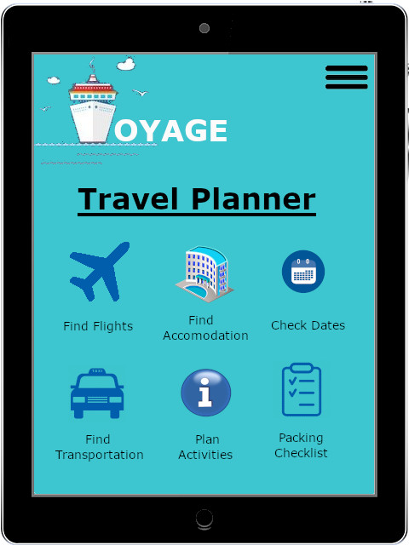

Prototype of the Travel Planner page

**Extra Features**

**Storing Important Documents**

While you are travelling, the last thing you need to be doing is wondering what could go wrong. One of the worst things that could possibly happen to you while overseas is to lose your passport or any important permits to enter certain areas. Our app would have that covered for you; these documents could be securely stored in our database for easy retrieval on request to keep you from getting stuck in a sticky situation. All these sensitive documents would be stored securely and encrypted for the safety and privacy of the client. Some documents may not be able to be simply printed out, in that case there would be a link to any relevant websites and important phone numbers that might be required to re-acquire those documents for you.

**Hidden Gems Map**

In most of the popular travel destinations there are the local attractions that everyone knows about. While they may be nice places to visit, there are always some not so well-known places that only the locals know about. These places sometimes turn out to be the most beautiful places and well worth visiting. Voyage will have a map of the local area with all these hidden gems that are available to visit and allow you to book an outing to them where applicable. Where booking is not required, we will provide local maps of these gems so you will not get lost and can explore without fear of losing your way.

**Wishlist**

Most people have many different destinations that they would like to travel to. Unfortunately, not everyone can just travel when they want to endlessly. That is why we have created a wish list, where you can enter all the details of the trip you want to take and save it to your wish list. Periodically Voyage will send an email advising the client of when is the best time to travel to that destination as well as when there are cheap deals on flights or accommodation.

**Traveler Profile and Journal**

Memories are the reason we travel. We have created a personal profile and journal that allows the user to document every trip. Upload photos, videos and audio files to your travel journal so that you can access them later. The ability to document every trip is something we have thought of. Having a private journal that you can use to keep track of experiences that you have had is worth its weight in gold. All these things are kept private and secure unless you decide to share them either on social media or anywhere else.

**Business Profile**

Here at Voyage we know the importance of word of mouth and networking. Which is why we have decided to incorporate a business profile for the users. Here you can enter the details of your business and we can share these details with the relevant parties and partners should an opportunity arise. This will help to not only improve our relationships but also to help our clients to expand their businesses if they wish to.

**Blog**

We have set up our own travel blog to allow its users to document experiences while traveling. They can rate the service they have received at any of the places they have visited. 84% of people trust online reviews as much as their friends[3]. On top of the review side of the blog, people can check on how good or bad real people’s experiences are at certain places.

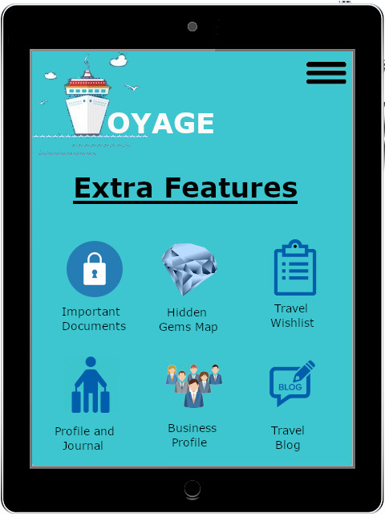

Prototype of the extra features page

1. <https://www.goodreads.com/quotes/131747-to-travel-is-to-live>
2. <https://www.statista.com/topics/962/global-tourism/>
3. <https://www.inc.com/craig-bloem/84-percent-of-people-trust-online-reviews-as-much-.html>